CS 340 README Template

About the Project/Project Title
CRUD Python Module for MongoDB, Austin Animal Center Dataset

This project implements a reusable Python module that provides full Create, Read, Update, and Delete (CRUD) functionality for a MongoDB database using the PyMongo driver. The module was developed using the Austin Animal Center (AAC) Outcomes dataset and is designed to support future client-server and dashboard-based applications for the Grazioso Salvare project.

The module encapsulates all MongoDB access logic inside a single Python class, allowing other scripts and applications to interact with the database without directly managing database connections or query logic. This modular design follows object-oriented programming best practices and improves reusability, maintainability, and security.
Grazioso Salvare Rescue Dashboard
This module was later extended and integrated into an interactive web dashboard using the Dash framework. The CRUD module now serves as the Model component of a full Model View Controller (MVC) architecture supporting the Grazioso Salvare Rescue Dashboard.
CRUD Python Module
The purpose of this module is to provide a clean and secure database access layer that can be reused across multiple applications. Instead of embedding MongoDB queries directly into application code, all database operations are centralized within the AnimalShelter class. This abstraction allows client-side code, such as dashboards or APIs, to interact with the database through methods while keeping authentication and query logic isolated.

Motivation
The motivation behind this project is to establish a clean and portable database access layer that can be reused across multiple applications. Rather than embedding MongoDB logic directly into application code, this module centralizes Create, Read, Update, and Delete (CRUD) operations in a single class. By creating this module early, future projects, such as dashboards or APIs, can build on a tested and reliable database interface instead of rewriting database logic from scratch.

Getting Started
To get a local copy of this project up and running, follow these steps:
- Install and run MongoDB locally.
- Import the desired dataset into MongoDB.
- Create a database user with read and write permissions.
- Place the CRUD Python module and testing file in the same project directory.
- Run the test script to validate Create, Read, Update, and Delete (CRUD) functionality.

This module assumes the use of the aac database and the animals collection created during testing.

Installation
Required Tech stack:
- MongoDB, used as a NoSQL database
- Python3
- PyMongo

PyMongo was used in this project because it is the official and fully supported Python driver for MongoDB. Using it provides direct access to MongoDB’s query and update APIs, as well as supports authentication and indexing, and integrates cleanly with Python applications. Using PyMongo ensures reliability, long-term support, and compatibility with MongoDB best practices.
MongoDB Import Execution:
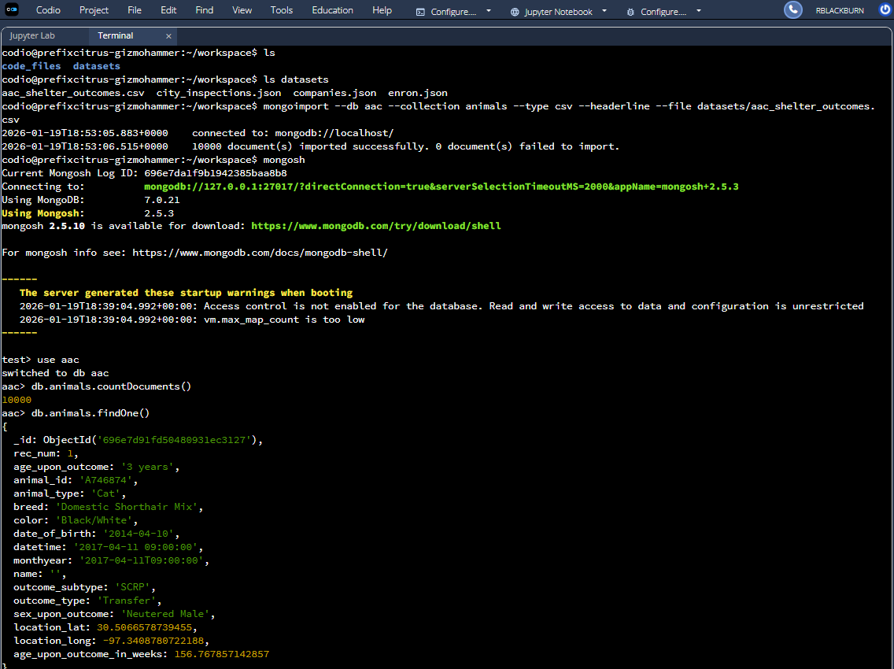
Authentication and Database Access
The MongoDB database uses credential based authentication to ensure secure access. A dedicated user account (aacuser) was created with read and write permissions for the AAC database. The CRUD module requires valid credentials to establish a connection, preventing unauthorized database access.

CRUD Module Usage

The AnimalShelter class provides the following methods:

Create – Inserts a new document into the database and returns True if the insert is successful.

Read – Queries the database using key/value lookup pairs and returns the results as a list.

Update – Modifies one or more documents that match a query and returns the number of documents updated.

Delete – Removes one or more documents that match a query and returns the number of documents deleted.

Code Example
shelter = AnimalShelter(username="aacuser", password="your_password_here")
# Create
shelter.create({"animal_type": "Dog", "name": "ExampleDog"})
# Read
results = shelter.read({"name": "ExampleDog"})
# Update
shelter.update({"name": "ExampleDog"}, {"color": "Black"})
# Delete
shelter.delete({"name": "ExampleDog"})

Tests
The test script:
- Imports the CRUD Python module.
- Calls the AnimalShelter class.
- Inserts a test document into the MongoDB collection.
- Queries the database to retrieve the inserted document.
- Confirms successful Create, Read, Update, and Delete operations.

Dashboard Integration:
In dashboard, the read() method of the AnimalShelter class is used to dynamically retrieve filtered data from MongoDB based on user-selected rescue criteria. These filtered results are then displayed in an interactive Dash DataTable and visualized using Plotly and Dash Leaflet components.

Screenshots
Import Execution:

User Authentication:
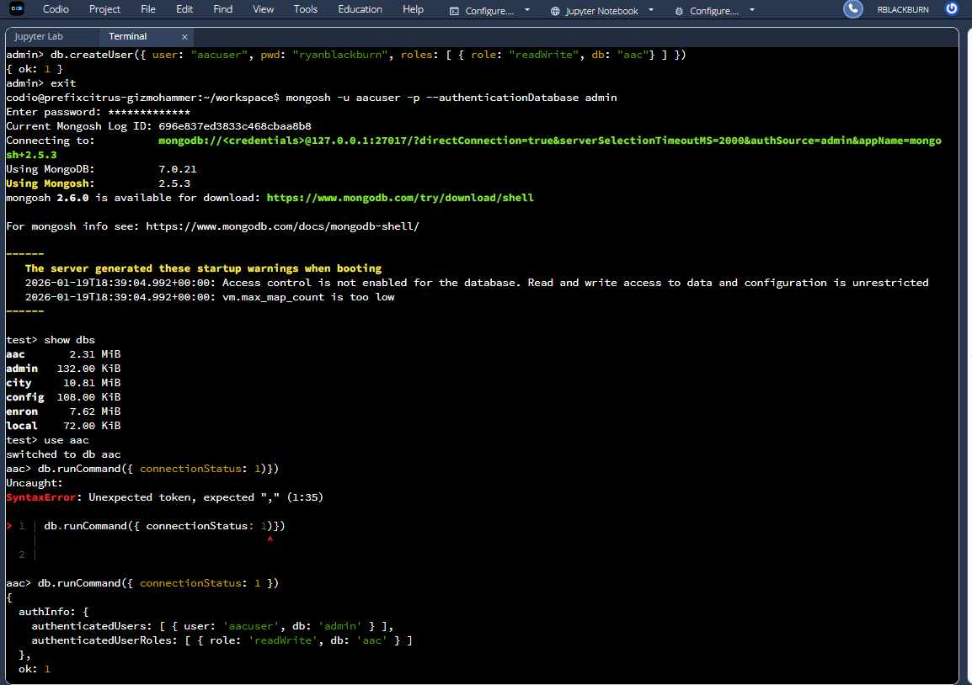
CRUD Functionality Test Execution:
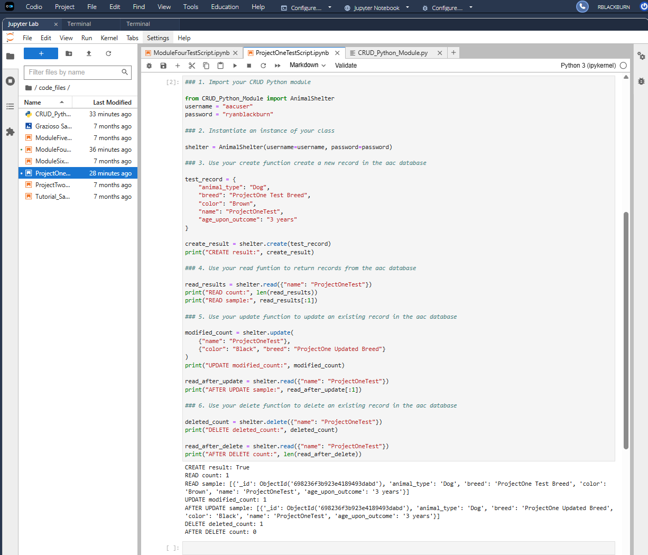

Project Two - Grazioso Salvare Rescue Dashboard
Required Functionality
The completed dashboard provides the following functionality:
- Provides interactive filtering widgets (RadioItems).
- Displays results in an interactive Dash DataTable.
- Updates a pie chart dynamically, based on filtered results.
- Displays a geolocation map that updates based on selected table rows.
- Includes a reset filter that restores the original dataset.
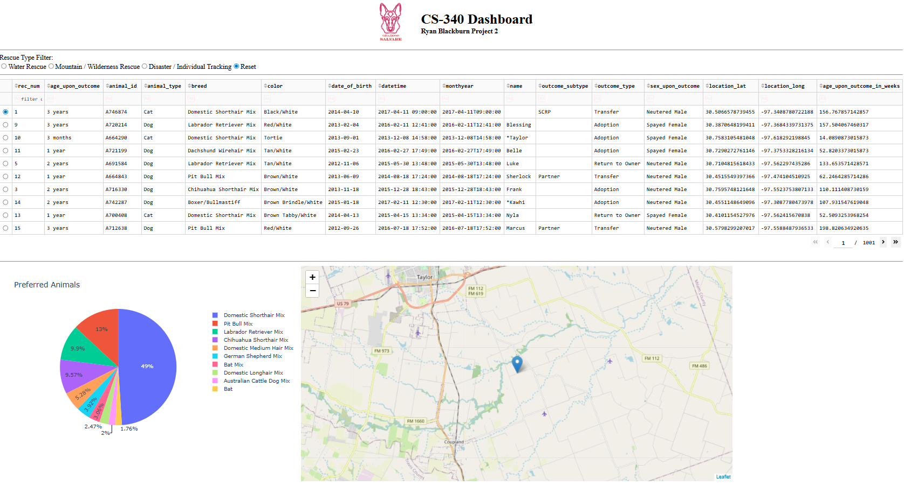
The dashboard can also be filtered to display the following types of events:
Water Rescue
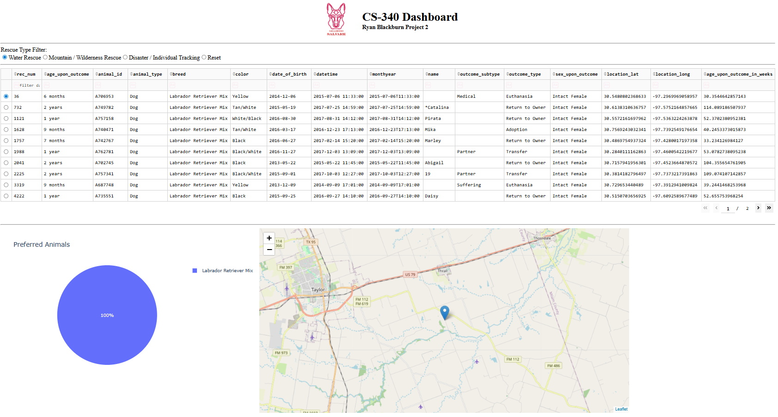

Mountain or Wilderness Rescue
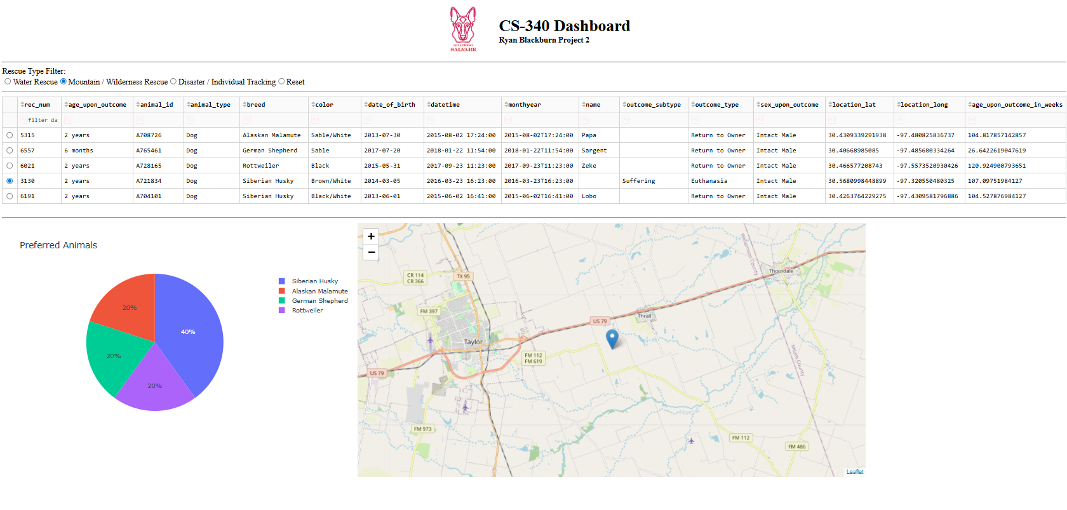
Disaster or Individual Tracking
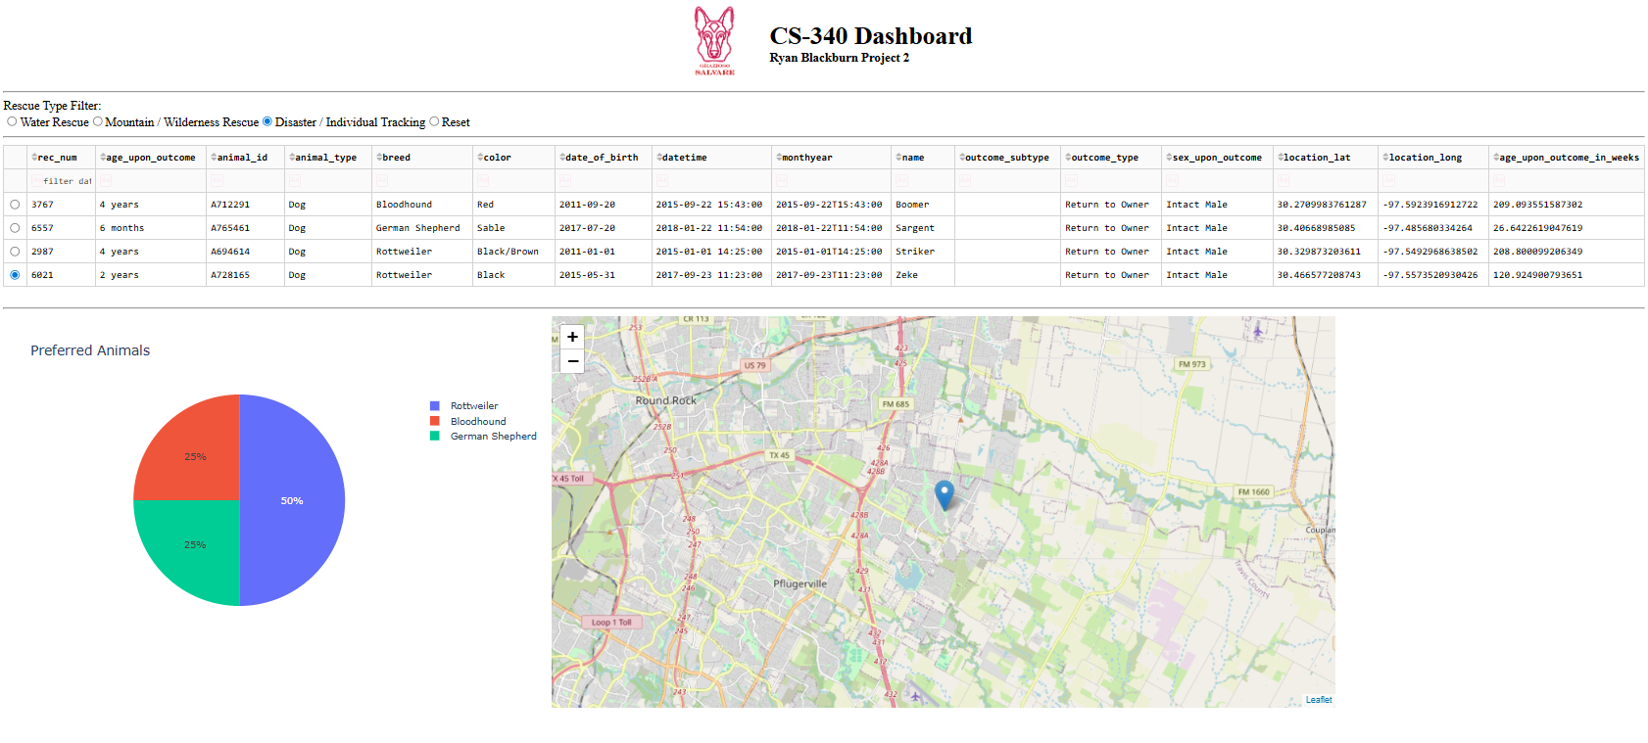
If the user wishes to return to the original state, the Reset button will restore all defaults.
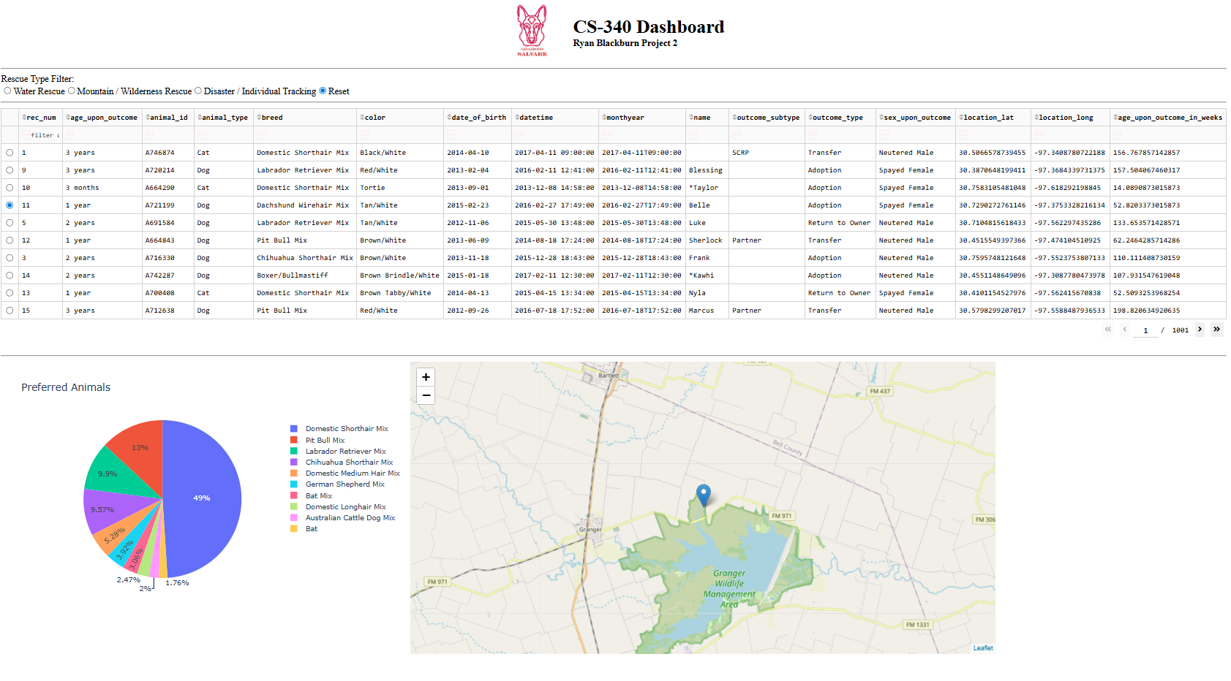

Tools used
MongoDB
https://www.mongodb.com/docs/
MongoDB was selected as the Model layer in the application architecture, because:
- It stores data in flexible document format.
- It supports powerful filtering operators such as $in, $gte, and $lte.
- It integrates directly with Python through the PyMongo driver.
- It allows efficient querying of large datasets without requiring schema migrations.
PyMongo
https://pymongo.readthedocs.io/
PyMongo is the official MongoDB driver for Python and was used because:
- It provides secure authentication support.
- It allows structured query construction.
- It integrates seamlessly with Python and Pandas.
Dash Framework
https://dash.plotly.com/
Dash was used to implement the View and Controller components of the web application. This was chosen because Dash callbacks link user interface selections to MongoDB queries through the CRUD module, which enables dynamic filtering and visualization.
Dash also allows:
- Reactive UI components using callbacks.
- Automatic updates of charts and tables without page reload.
- Integration of Plotly charts and Leaflet maps.
- Full Python-based development without writing JavaScript.
Plotly Express
https://plotly.com/python/
Plotly Express was used in the project for generating the interactive pie chart, which represent and visualize the distribution of breeds. Plotly Express allows rapid aggregation and clean visualization with minimal code.
Dash Leaflet
https://dash-leaflet.herokuapp.com/
Dash Leaflet is used in the project to render the interactive map component. It was chosen because it supports dynamic marker placement and map recentering based on user selection.
Steps to Project Completion:
Verified MongoDB database and authentication setup.
The MongoDB database was confirmed to be running locally with proper authentication. A dedicated user account was used for secure read access for the dashboard.
Confirmed CRUD module functionality.
Create, Read, Update, and Delete operations were tested to ensure communication between Python and MongoDB was functioning.
Connected dashboard to CRUD module.
The Dash application imports the AnimalShelter class and uses its read() method to retrieve database records dynamically, based on user selection.
Loaded MongoDB data into Pandas DataFrame.
MongoDB query results are converted into a Pandas DataFrame to enable structured manipulation; also compatibility with Dash DataTable and Plotly components.
Implemented interactive radio button filters.
Dash RadioItems were added to allow users to select predefined rescue types. This also enabled dynamic filtering of database records.
Constructed MongoDB queries for each rescue type.
Specific query dictionaries were created using MongoDB operators to match breed, age, and sex criteria for each rescue scenario.
Connected filters to DataTable via Dash callback.
Implemented a Dash callback function, executes appropriate MongoDB query when a filter option is selected, then updates the DataTable.
Implemented dynamic pie chart reflecting filtered data.
Callback created to aggregate breed counts from the currently visible table data and generate a Plotly pie chart.
Implemented dynamic Leaflet map.
Dash Leaflet is used to render an interactive map that displays a marker for the selected animal, based on stored latitude and longitude coordinates.
Challenges and Solutions
Challenge 1: Dash Callback structuring
When configuring the initial callback functionality, I encountered conflicts when attempting to update and found that incorrect return types were being returned.
Resolution was found by restructuring the callback to properly return (data, columns) and then ensuring that callback definitions were unique and not repeated.
Challenge 2: MongoDB ObjectId Serialization
Found that the Dash Datatable could not serialize MongoDB ObjectId types.
Resolved by removing _id column, rendering continued unharmed from there.
Challenge 3: Map Center not updating
When making different selections, the marker would move properly but map was set to a single geolocation by GPS coordinates.
Resolved conflict by implementing camera controls inside the map callback to explicitly center, using:
center=[lat, lon]
zoom=12
This corrected the map behavior and improved coherence and ease of use.

Contact
Your name: Ryan Blackburn

